Exp. No: 5 Determination and plotting of Electric potential difference between any two points in free space medium separated by a distance R.

Aim:
To write program for Electric potential difference between two points in free space medium using SCILAB.
Software required:
•SCILAB version 6.0.1
Code:
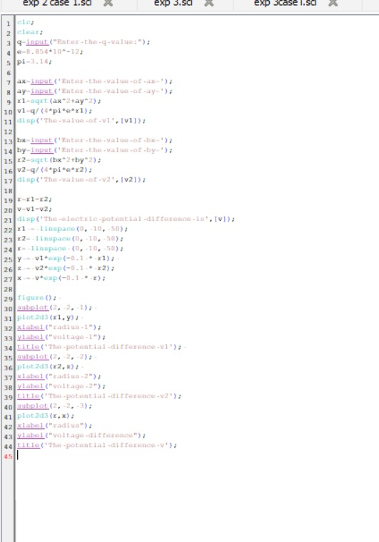

Output:

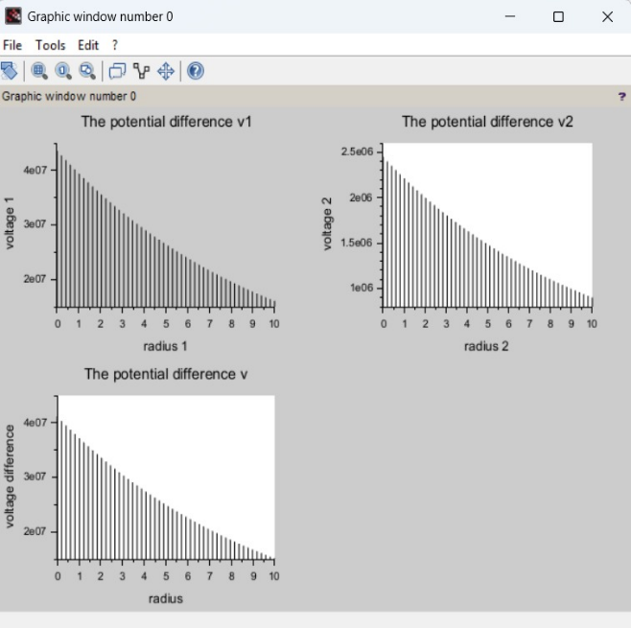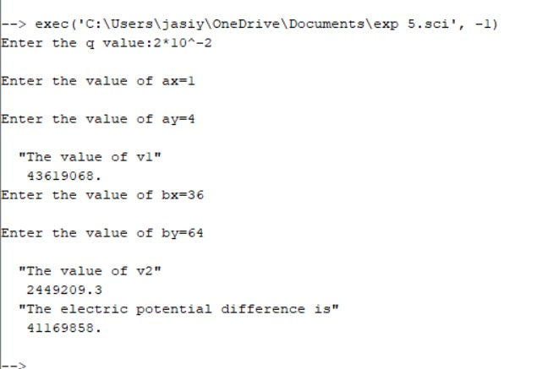
Case 1: A positive charge with fixed r1=1 m r2 varying.
Code: output:
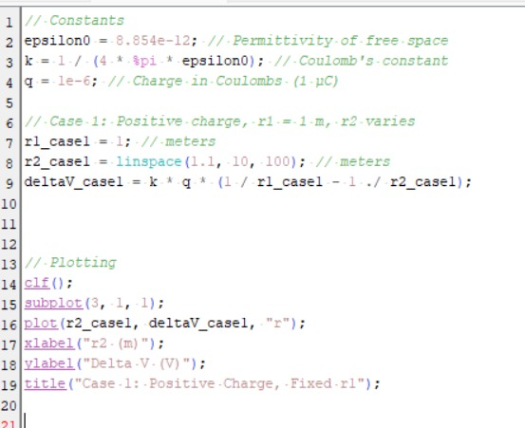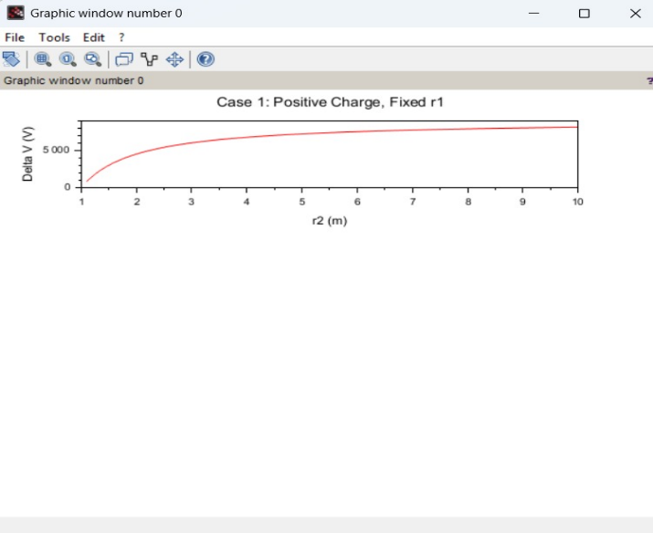
Case 2: A negative charge with r1r_1r1​ fixed and r2r_2r2​ varying.

Code: output:
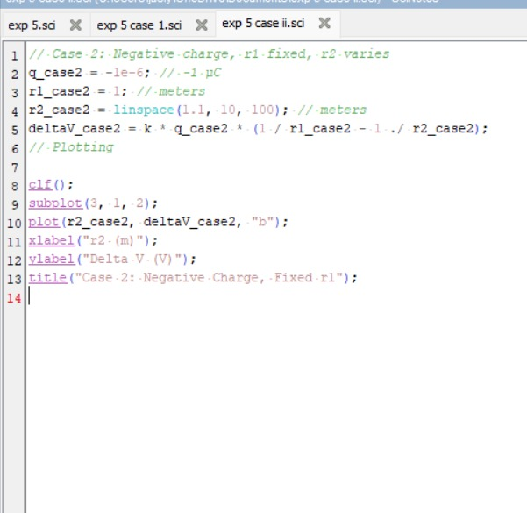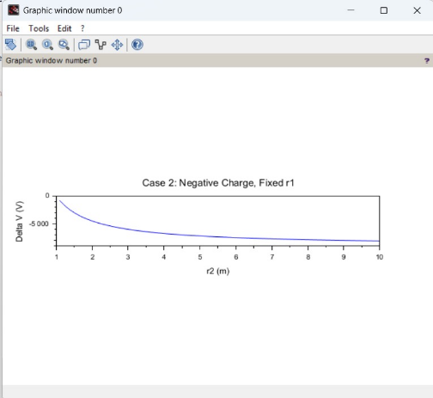
Case 3: Both points r1r_1r1​ and r2r_2r2​ vary with a positive charge.
Code: output:
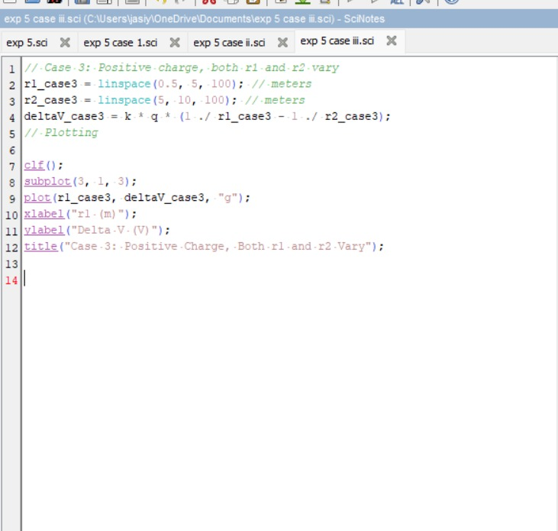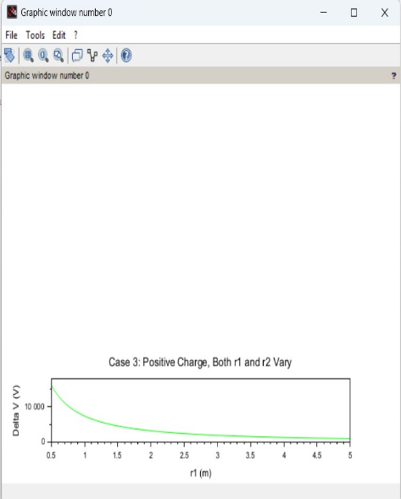
Result :
Thus the program was verified for Electric potential difference between two points in free space medium using SCILAB was successfully.

